1. Document analyse:
Actors: Casual Art Buyer, Art Collector, Artist, Art Dealer
Use cases:
1. Browse Artworks
2. View Artwork Details
3. Save Artwork to Wishlist
4. Purchase Artwork
5. Participate in Auction
6. Upload Artwork
7. Manage Artwork
8. Handle Commission Requests
9. Manage Artists & Artworks
10. Verify Artwork Authenticity
2. Use Case Diagram
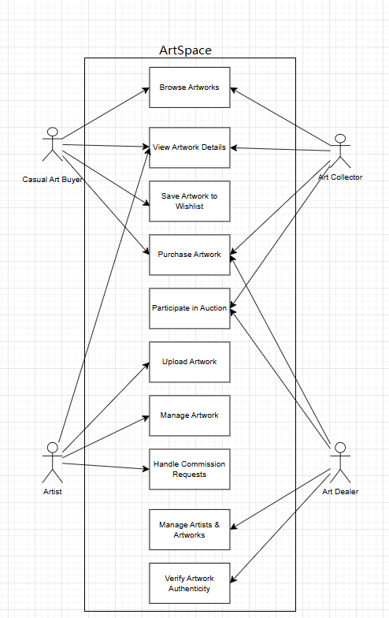
3. Tutorial Discussion Questions
• 1. What is UML? Why do we need this?
UML (Unified Modeling Language) is a standardized visual modeling language used to represent, design, and document software systems. It provides a set of diagrams and notations to describe system structure and behavior.
We need UML because it helps developers, analysts, and stakeholders clearly communicate system requirements and design. It improves understanding, reduces ambiguity, and provides a common language for system development.

• 2. What does a use case diagram represent and what are the different elements of a
use case diagram?

A use case diagram represents the functional requirements of a system from the user’s perspective. It shows how different actors interact with the system to achieve specific goals.
The main elements of a use case diagram include:
1. Actors (external users or systems)
2. Use cases (functionalities or actions)
3. System boundary (defines the scope of the system)
4. Associations (relationships between actors and use cases)

• 3. What are we documenting when we place a use case on the diagram?

When we place a use case on the diagram, we are documenting a specific functionality or goal that the system must provide to its users. It represents what the system is expected to do from the user’s perspective.

• 4. What are we documenting when we place an actor on the diagram?

When we place an actor on the diagram, we are documenting a role that interacts with the system. It represents who uses the system or who communicates with it.

• 5. Which of the following could be an actor found on a use-case diagram? Why?

Ms. Mary Smith, Supplier, Customer, Internet Customer, Data Entry Clerk, Database Administrator

The following can be actors:
Supplier, Customer, Internet Customer, Data Entry Clerk, Database Administrator
The following should NOT be an actor:
Ms. Mary Smith
Reason:
Actors represent roles, not specific individuals. “Ms. Mary Smith” is a specific person, while the others represent general roles that can interact with the system.

• 6. How is use-case diagramming related to functional modeling?

Use case diagramming is a form of functional modeling because it focuses on representing the system’s functionalities and how users interact with those functions. It helps identify and organize functional requirements at a high level.

• 7. Why do we draw association lines between actors and use cases?

Association lines are drawn to show the interaction between actors and use cases. They indicate which actor is involved in a particular use case and who initiates or participates in the action.

